SOFTWARE ENGINEERING  
COMPONENT DIAGRAM  
ONLINE SHOPPING WEBSITE  
 Name:p.swathi

Redgno:2023004583  
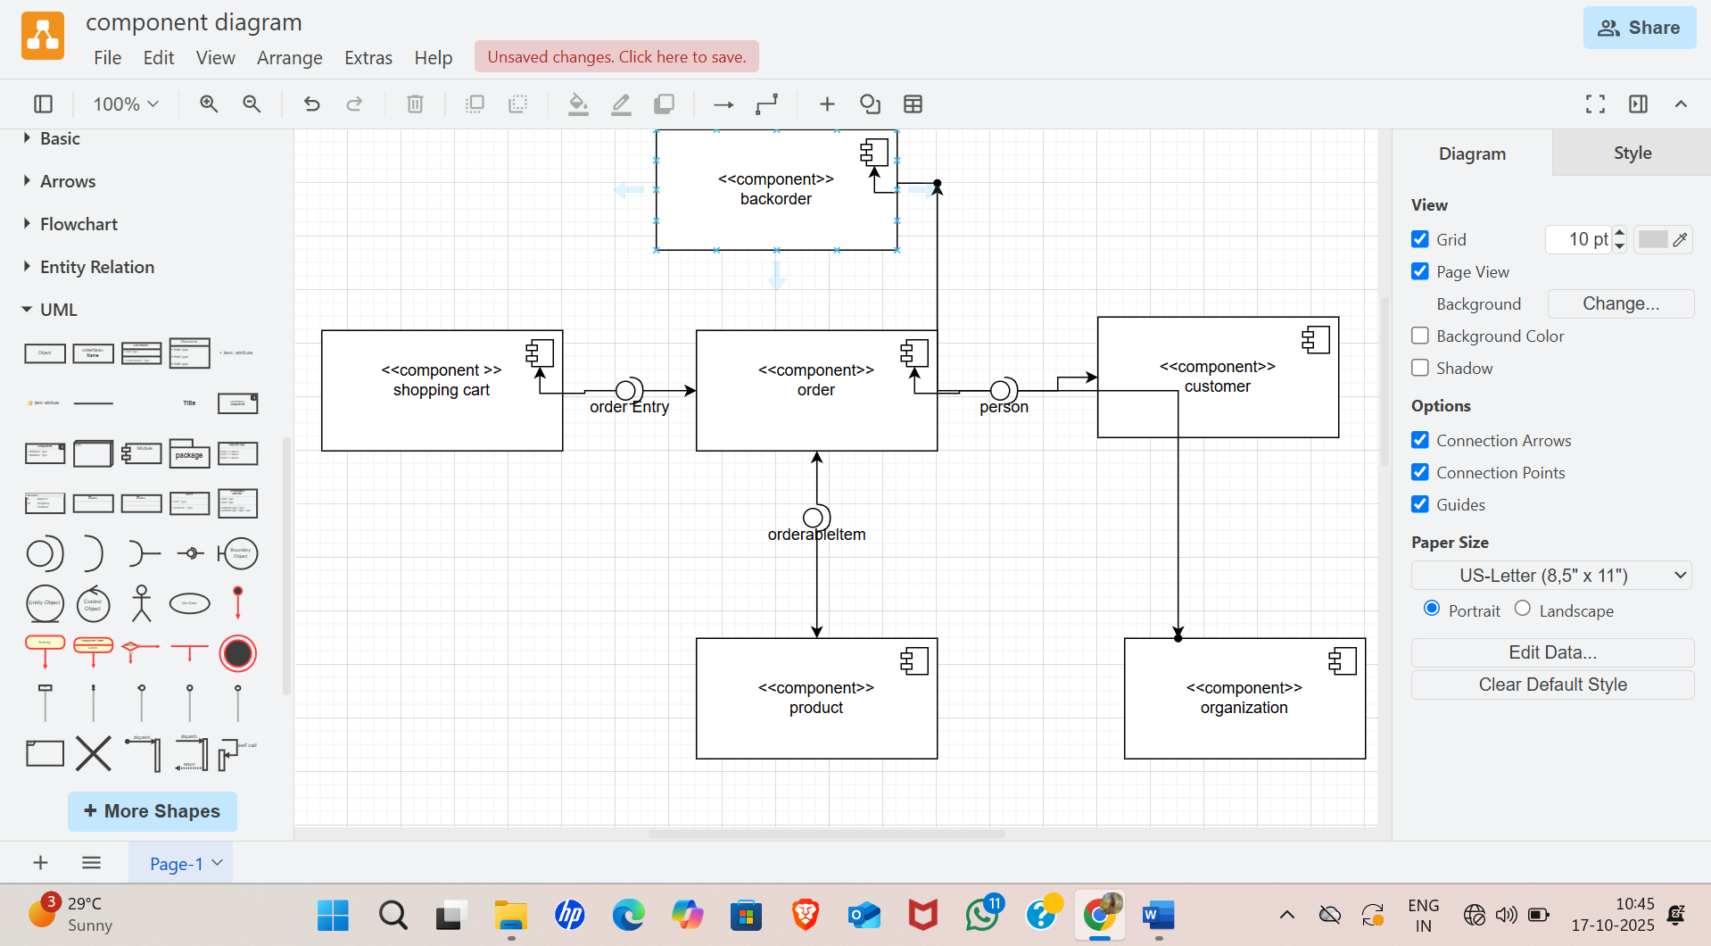  
COLLOBARATION DIAGRAM

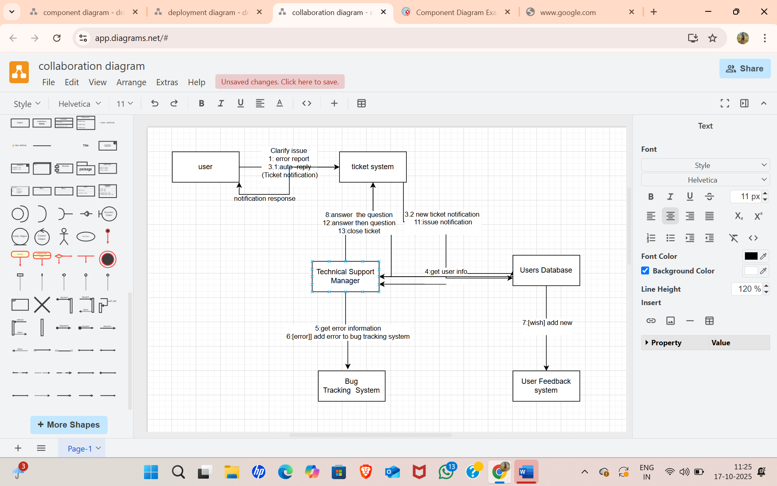

DEPLOYMENT DIAGRAM

